**Machine Learning (Assignment # 3)**

**Name** : Mounika Kandula

**Student Id**:700747570

**GitHub Link**:

**Video Link**:

**Question 1:Numpy**

**a. Using NumPy create random vector of size 15 having only Integers in the range 1-20.**

**1. Reshape the array to 3 by 5**

**2. Print array shape.**

**3. Replace the max in each row by 0.**

**Create a 2-dimensional array of size 4 x 3 (composed of 4-byte integer elements), also print the shape, type and data type of the array.**

**Solution:**

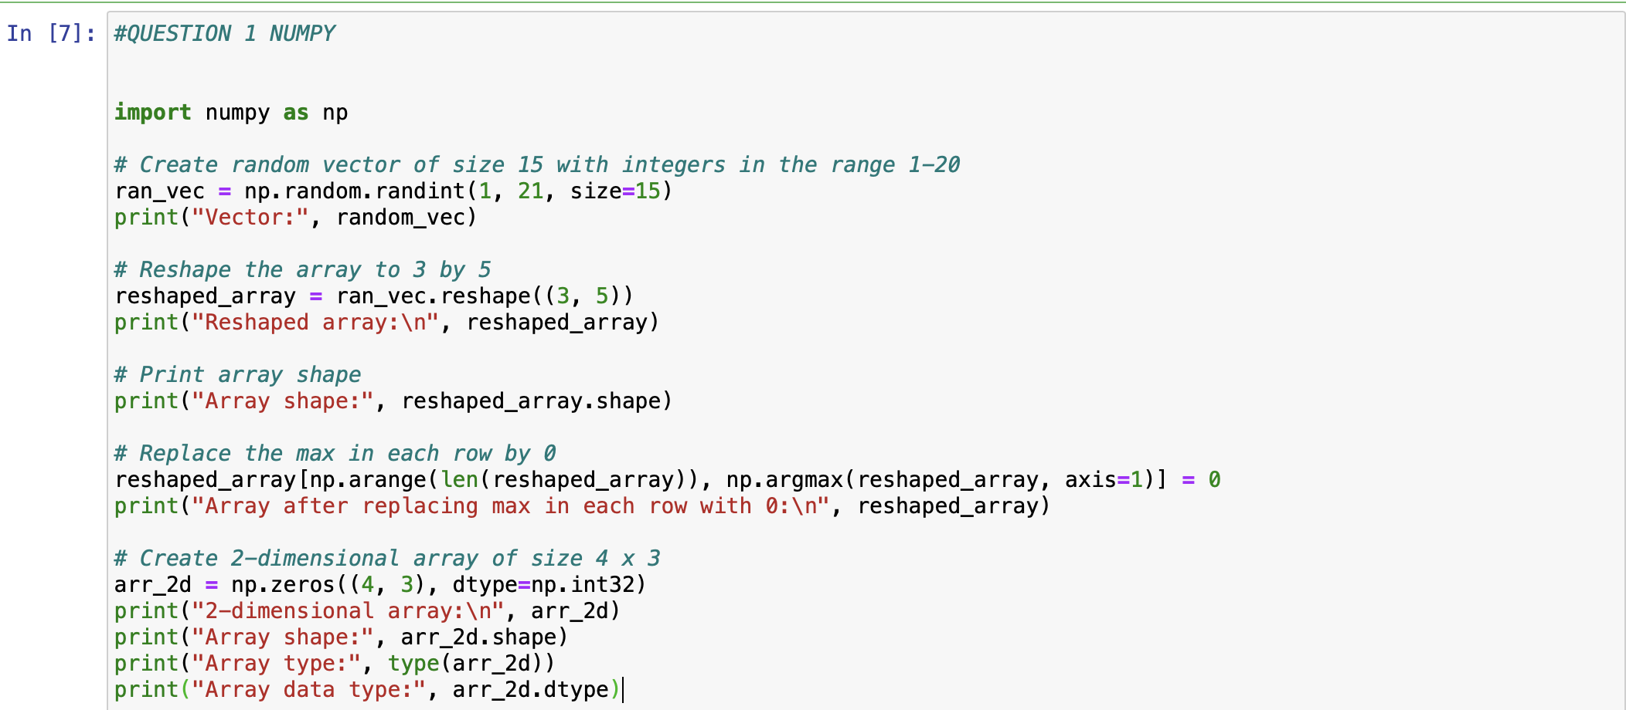

**Output:**

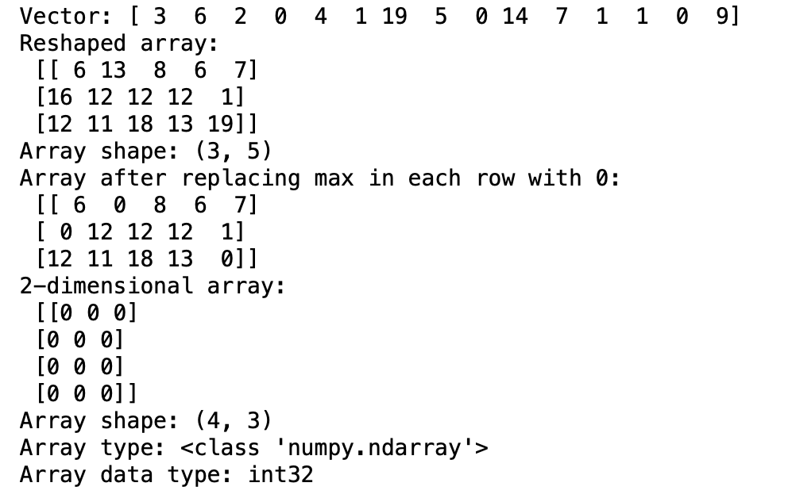

**b. Write a program to compute the eigenvalues and right eigenvectors of a given square array given below:**

**[[ 3 -2]  
[ 1 0]]**

**Solution b:**

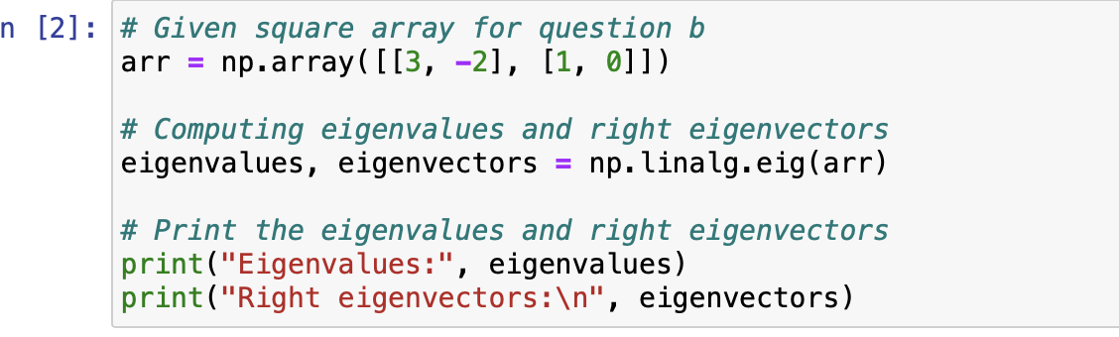

**Output:**

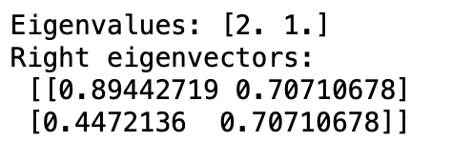

**c. Compute the sum of the diagonal element of a given array.  
[[0 1 2]  
[3 4 5]]**

**Solution C:**

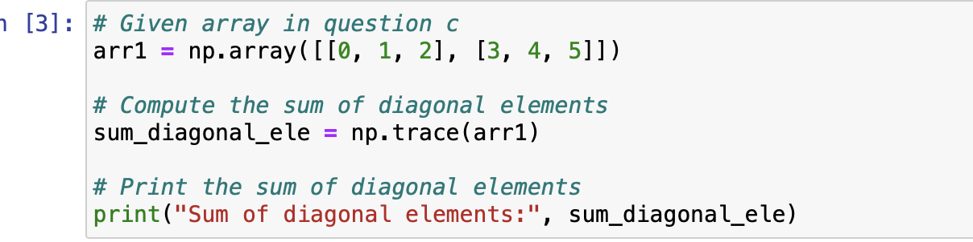

**Output:**

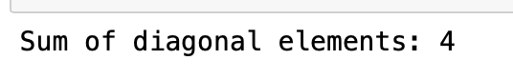

**d. Write a NumPy program to create a new shape to an array without changing its data.**

**Reshape 3x2:  
[[1 2]  
[3 4]  
[5 6]]  
Reshape 2x3:  
[[1 2 3]  
[4 5 6]]**

**Solution d:**

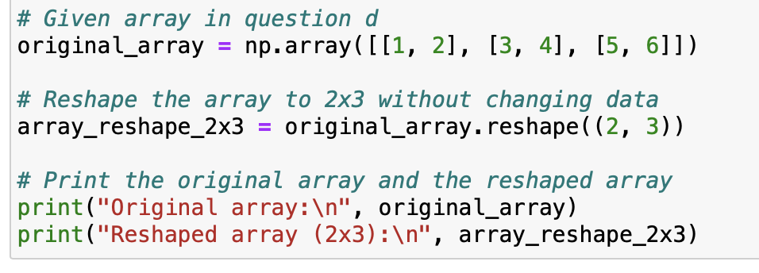

**Output:**

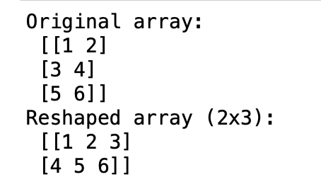

**2. Matplotlib**

1. Write a Python programming to create a below chart of the popularity of programming Languages.
2. Sample data:

Programming languages: Java, Python, PHP, JavaScript, C#, C++ Popularity: 22.2, 17.6, 8.8, 8, 7.7, 6.7

**Solution:**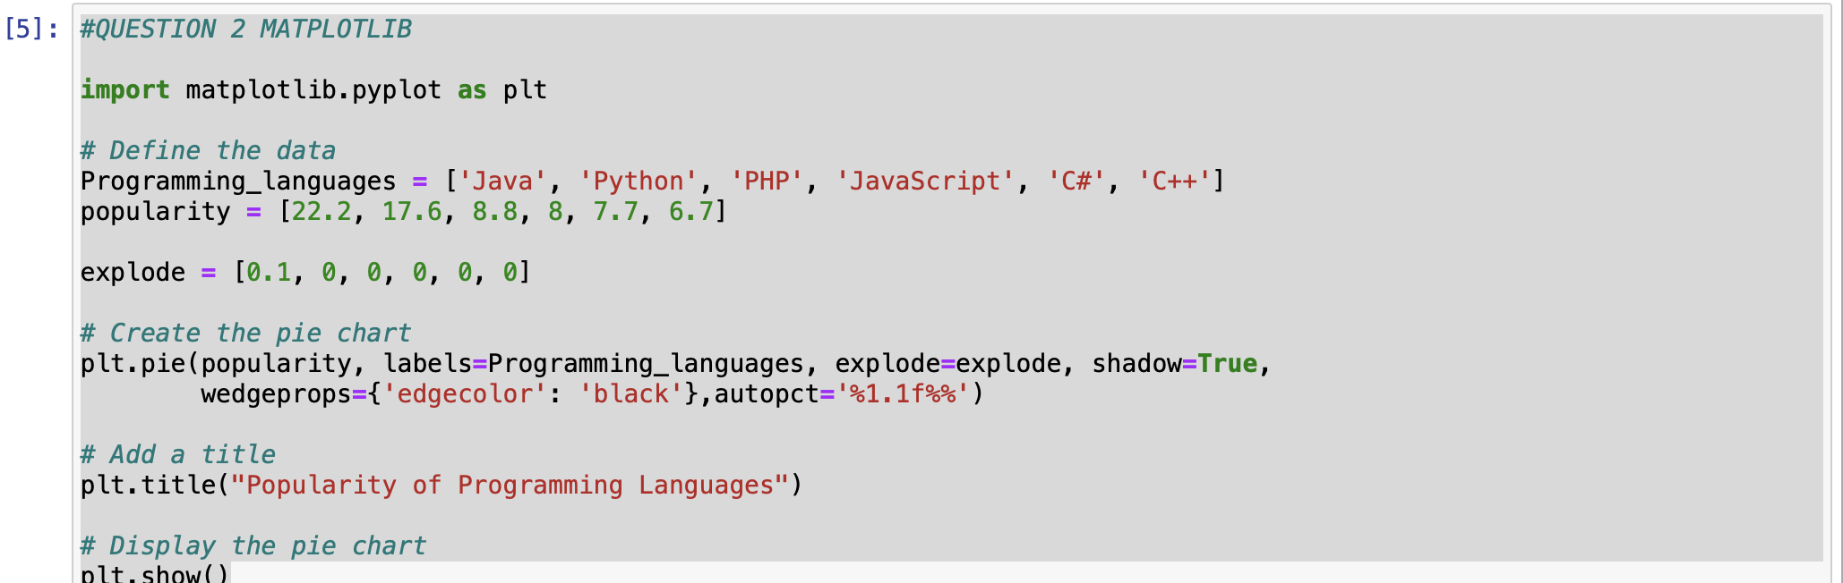

**Output:**

